Please find below the instructions to the test. Upon completion, please send us your results. Our Tech team will review the results and I will get back to you as soon as possible.  
  
Login to: 13.57.17.1  
  
with the pem file in attachment:

Install this application <https://github.com/symfony/symfony-demo> and make it runnable with nginx - Add a monitor application to ensure the symfony app is running (example: zabbix)

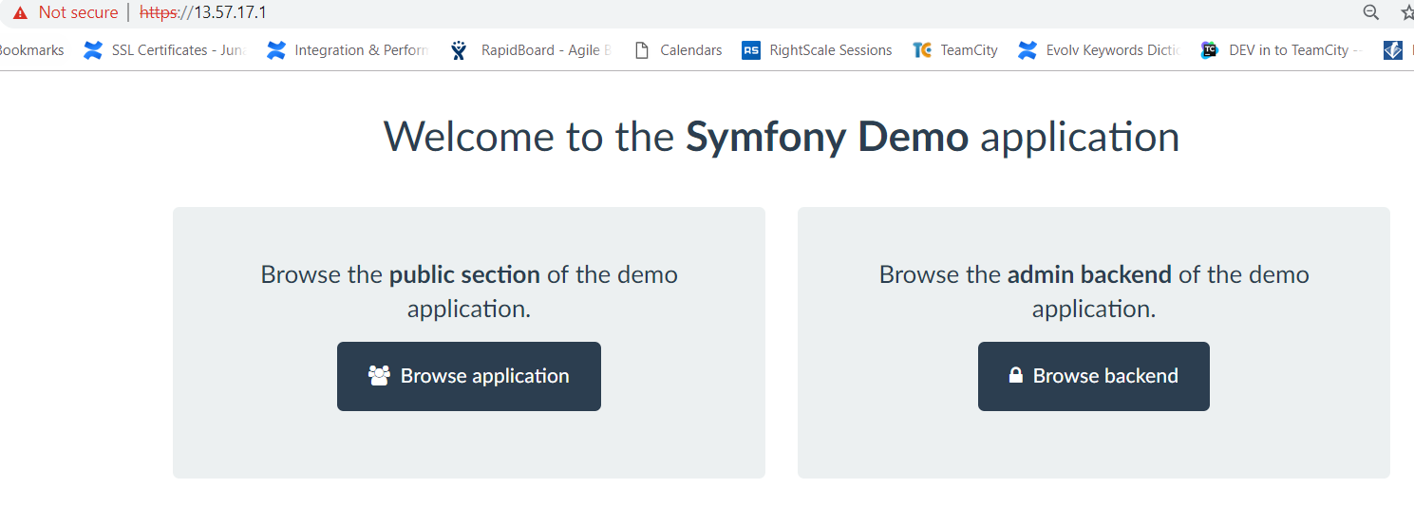

**Zabbix Monitoring**

It will update the URL and status after every 10 secs

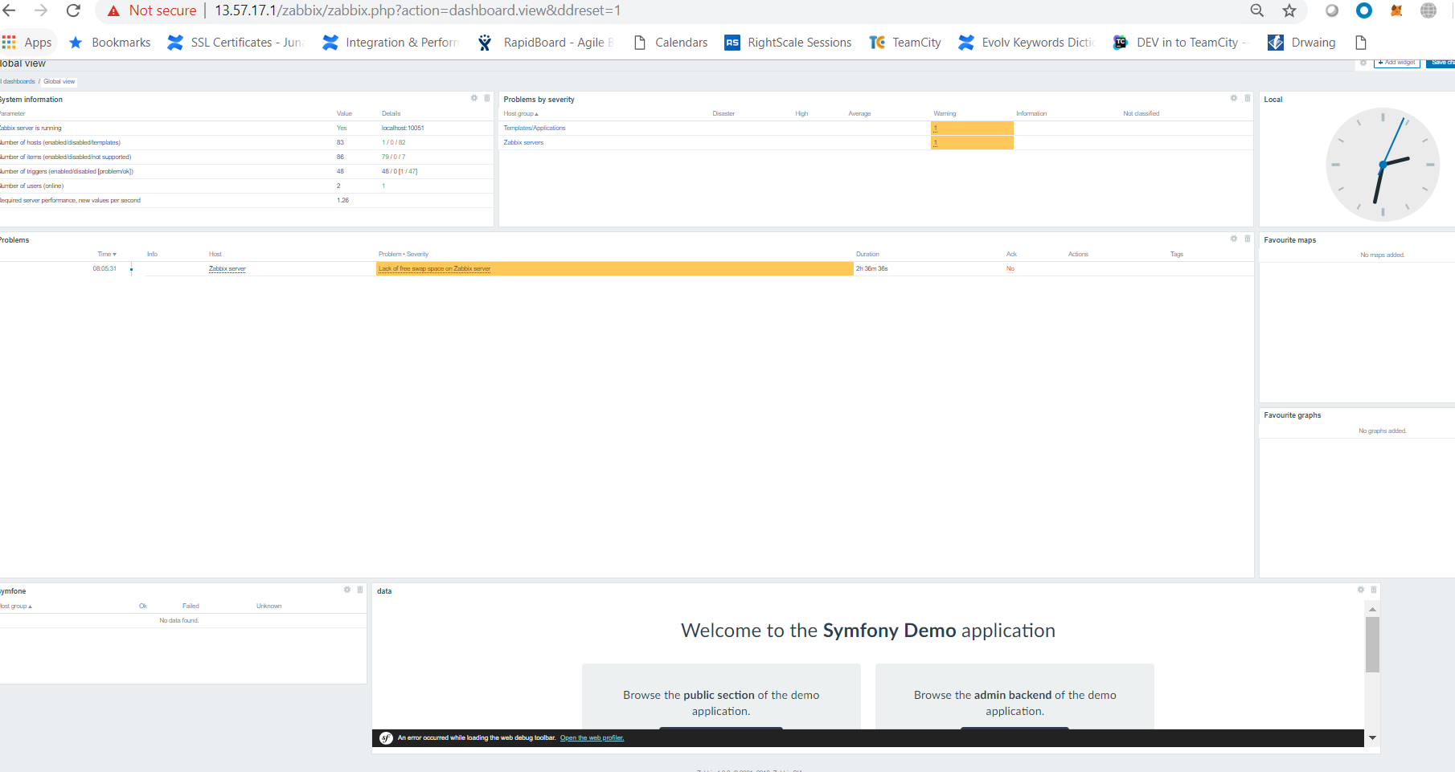

 Optimize and clean the machine

For Better Connection Handling, file system response, Prcossor Scheduler I have changed the following parameters on sysctl.conf. On this machine there is no swap memory, sometime to save the application from crash you have to assign the swap memory and in swapiness you handle the percentage of memory utilization before moving to the swap memory.

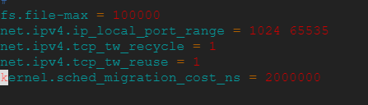

- What is the private ip of the machine?



Or can see from the ifconfig

What security concerns would you have about this machine

SeLinux is not installed / enabled in this machine

Unwanted apache2 was running on the machine

server_tokens off; > to prevent the details about OS

Enabled the following on NGINX for secure communication

listen — enable the SSL listener on port 443, i.e. the HTTPS port.

ssl_protocols — enable only these three, considered currently secure protocols - TLSv1 TLSv1.1 TLSv1.2.

ssl_ciphers — enable only these secure SSL ciphers: EECDH+AESGCM:EDH+AESGCM:AES256+EECDH:AES256+EDH

ssl_prefer_server_ciphers — make sure that the client respects the server's ciphers preferences.

ssl_dhparam — use the custom, strong DH parameters which we have generated earlier.

ssl_certificate — use our self-signed SSL certificate. Make sure to change it if you are using another certificate.

ssl_certificate_key — use our SSL private key, which we have previously generated.

We can configure WAPITI on Ubuntu it’s an auditing tool which scans for web vulnerabilities.

- Consider I want to automate the provisioning and the deployment for this project, how would you proceed with that task? give some examples

There are multiple ways to automate provisioning and deployment:

Use Orchestration and Management tools. These will allow you to manage and update configuration at any center location, from which changes are pushed out automatically to all managed nodes.

* ANSIBLE
* CHEF
* PUPET

Create the Micro Service Containerized the Application and using Kubernetes deploy the containers on AWS/Azure/GCS or local infrastructure without any downtime.

- Document what you did as if you would like to create a confluence page for future reference.

Usually for the technical guide it would be help full for other and you self if you create the end to end practical confluence reference page. On Confluence provide the actual commands of deployment, concept of the method you are using and some diagram for better understanding